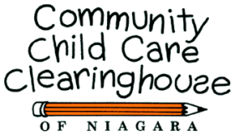
1521 Main Street
Niagara Falls
New York 14305
www.childcareofniagara.com
Toll Free: 1-800-701-4KID
Phone: 716-285-8572
Fax: 716-286-9243
E-mail: ccrrniagara@niagaracap.org

Spring NEWSLETTER 2020

Newsletter for Niagara County Child Care Providers, Parents & Child Advocates

Did you know children actually grow faster in the spring than during other times of the year? Fascinating!
(https://www.factretriever.com/spring-facts)

It’s important to take the time to sing, read and do projects with a child whether it’s coloring, painting, fixing lunch. It helps to develop imagination.

Spring is the perfect time to have children plant flower or vegetable seeds. It provides children with the opportunity to learn how to care for and watch living things grow.

I remember having a great time sowing grass seed on a wet sponge. It’s an easy project but it still needs to be watered and cared for. In the newsletter, look for a craft project children can do with grass and/or plants to take home.


Celebrate!
Be on the lookout for that perfect spring day for a picnic at a park or your own backyard! If possible, include family, friends or an older neighbor. If this is done as part of a day care, be sure any guests (including the Easter Bunny) sign in and out.

Have a simply marvelous, fun day!
Carolyn
“There are three ways to ultimate success: The first way is to be kind. The second way is to be kind. The third way is to be kind.”
– Mr. Rogers



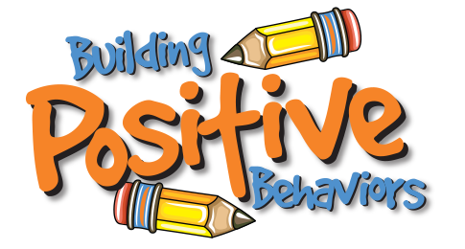
10 WAYS
To Increase Positive Behavior

By Angela Percival-Porter
Article Link:
https://www.childcareexchange.com/article/10-ways-to-increase-positive-behavior-in-early-care-and-education-centers/5025046/

Having a variety of tools and techniques to use helps the whole day care environment. While they will not work for all children, having several tricks up your sleeve will increase positive behavior. Here are 10 ways to increase positive behavior in early care and education programs.
1. “Do the Dos,” not the “Do nots”
Tell children exactly what you do want them to do. Children habituate to “Do not,” “No,” “Stop,” “Quit,” etc. For instance, instead of saying “No standing in the chair,” say, “Put your feet on the floor.” Instead of “stop hitting,” try, “please keep your hands to yourself.” It takes practice, but you will be surprised at the results!
2. Offer Choices/Avoid Asking
Choices empower children and smooth the way through transitions. For example, instead of asking “Do you want to go inside?” say, “It is time to go inside. Do you want to tiptoe or fly in?” Instead of asking “Do you want to paint?” say, “It is time to paint. Do you want the red paint or blue paint?” Offering choices gives children control, which decreases pushback by allowing them a genuine sense of independence.
3. Use Healthy Touch
Touch is not a want, it is a need. It is an interaction that shows respect and is required for proper physical and brain development. It is critical for social/emotional development. It stimulates all the systems of the body and releases hormones that reduce stress. When we reduce stress, we will experience happier, better behaved children and happier teachers. Incorporate healthy touch throughout the day.
4. Drink Water
Children need water at least every two hours for their systems to function properly and to set the stage for learning. When a child is thirsty, they have already begun the dehydration cycle. In addition, their cognitive abilities decrease 10 percent when they are thirsty. Offer water frequently and daily for optimal learning and positive behavior.
5. Play
We use play to connect and engage with children. We use play to teach social skills. We even use play to correct our children and reconnect with them after correction. Play in its sweetest, most tender form, permeates all that we do. Be silly, have fun, swing and sing.

6. Warnings with Consistent Boundaries
Provide boundaries that are simple, necessary and minimal. Remind children of them often. We learn through repetition. If it is a rule, then it is a rule. Be sure to follow through. For example, “George, if you throw the sand again you will have to go to another area.” If George throws the sand again, follow through and take him to another area.
7. Use Creative Games
Have clean up time races, play the quiet game, sing while washing hands, dance your way outside and so on. Using your imagination will invite children to use theirs, too.
8. Ask Questions to Prompt
“Hmmm, I wonder where this toy truck goes?” “Does anyone know where this book belongs?” “I wonder which activity is next?” “Is it outside time or lunch time?” Questions can smooth transitions and invite children to share their ideas and opinions.
9. Cues or Signals
Pick a few signals to use during transitions. You can flicker the lights, use a bell, use a timer or sing a song.
10. Visual Aids
Visuals are powerful tools when guiding a child through their day. Visuals give us an additional clue as to what is going to happen next. For instance, posters of children playing cooperatively in the dramatic play area. Visual schedules can also be used to guide children’s daily routines. When children know what is coming next, they feel less anxious, which in turn promotes positive behavior. Remember, when we reduce stress, we support happier, better behaved children and happier teachers.
Happy teaching; our future awaits!
Author Bio
Angela Percival-Porter has spent 29 years working with families and children, including serving as the director of an NAEYC-accredited early care and education center and providing mental health consultation for area child care centers. She is employed as a child development specialist for the State of Oklahoma and is an adjunct professor teaching a variety of child development and child care administration courses at a local state college. She is a nationally board certified teacher and earned her national director’s credential from National Louis University.



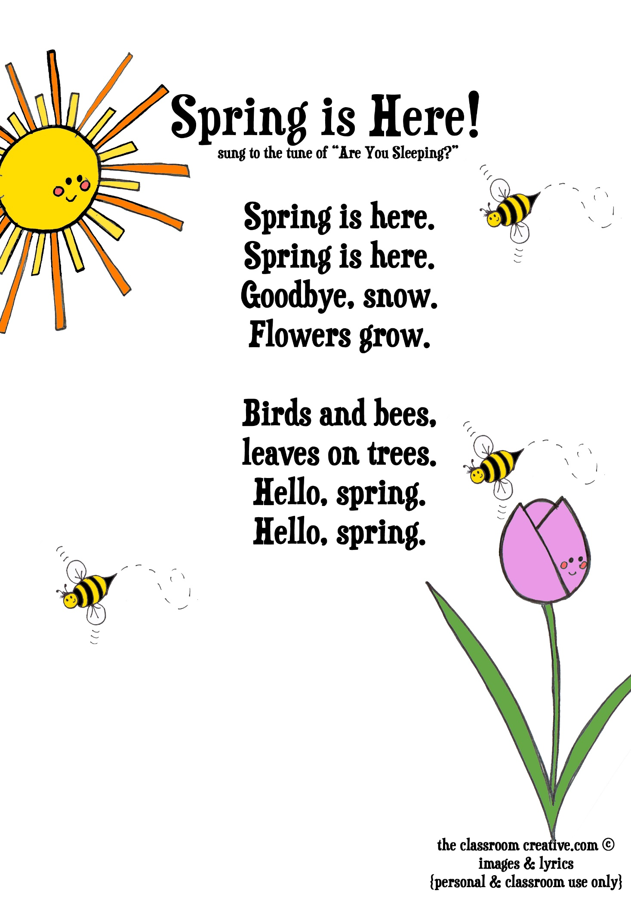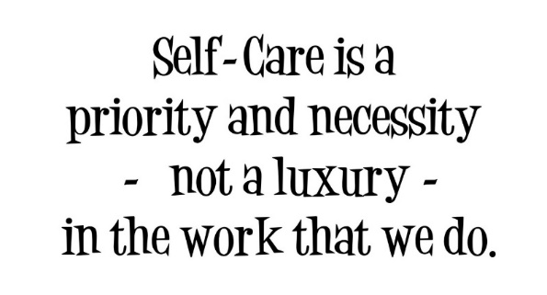
Americans are stressed. Sometimes the stress we face on a daily basis isn’t anything of our own making. Practicing good self-care is more important now than ever. It can be hard but taking time daily for yourself is a necessity. If we’re feeling out of sorts, stressed, children pick-up on that. One child may want to give you a hug, but it may cause another child to act up or withdraw.

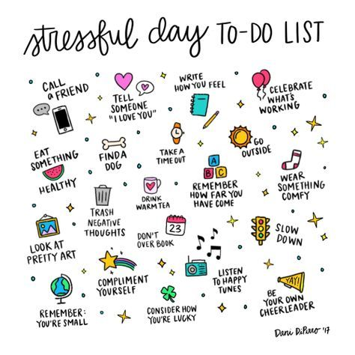
Each of us has our own list of favorites that we resort to in reducing stress.

For myself, curling up in a comfy chair with a good book and a great cup of decaf is exactly what I need. Other times I may need to go for a walk or be creative. Sometimes, it’s lunch with a friend.
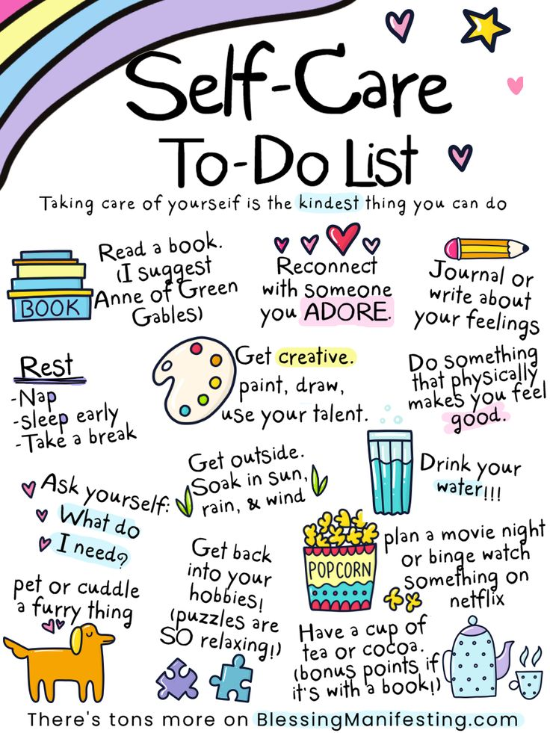
Children, also, feel the effects of stress:
- A test coming up at school.
- The neighborhood bully.
- Wanting their own way.

Children may not have the vocabulary skills to express what’s wrong. So their stress may be expressed in any number of ways such as a temper-tantrum, fighting, not wanting to go to school/daycare or withdraw from family and friends.

As parents and caregivers, we need to help children learn coping skills. As a child gets older, they need to learn to set aside time daily to practice good self-care.

Children learn so much from the adults in their life. So if a child sees the adults in their life taking time to practice self-care, they are more likely to do the same.

Kids and Food:
10 Tips for Parents

Reviewed by: Mary L. Gavin, MD
Date reviewed: September 2015
https://kidshealth.org/en/parents/eating-tips.html

It's no surprise that parents might need some help understanding what it means to eat healthy. From the My Plate food guide to the latest food fad, it can be awfully confusing.

The good news is that you don't need a degree in nutrition to raise healthy kids. Following some basic guidelines can help you encourage your kids to eat right and maintain a healthy weight.

Here are 10 key rules to live by:
- Parents control the supply lines. You decide which foods to buy and when to serve them. Though kids will pester their parents for less nutritious foods, adults should be in charge when deciding which foods are regularly stocked in the house. Kids won't go hungry. They'll eat what's available in the cupboard and fridge at home. If their favorite snack isn't all that nutritious, you can still buy it once in a while so they don't feel deprived.
- From the foods you offer, kids get to choose what they will eat or whether to eat at all. Kids need to have some say in the matter. Schedule regular meal and snack times. From the selections you offer, let them choose what to eat and how much of it they want. This may seem like a little too much freedom. But if you follow step 1, your kids will be choosing only from the foods you buy and serve.
- Quit the "clean-plate club." Let kids stop eating when they feel they've had enough. Lots of parents grew up under the clean-plate rule, but that approach doesn't help kids listen to their own bodies when they feel full. When kids notice and respond to feelings of fullness, they're less likely to overeat.
- Start them young. Food preferences are developed early in life, so offer variety. Likes and dislikes begin forming even when kids are babies. You may need to serve a new food a few different times for a child to accept it. Don't force a child to eat, but offer a few bites. With older kids, ask them to try one bite.
- Rewrite the kids' menu. Who says kids only want to eat hot dogs, pizza, burgers, and macaroni and cheese? When eating out, let your kids try new foods. They might surprise you with their willingness to experiment. You can start by letting them try a little of whatever you ordered or ordering an appetizer for them to try.
- Drink calories count. Soda and other sweetened drinks add extra calories and get in the way of good nutrition. Water and milk are the best drinks for kids. Juice is fine when it's 100%, but kids don't need much of it, 4 to 6 ounces a day is enough for preschoolers.
- Put sweets in their place. Occasional sweets are fine, but don't turn dessert into the main reason for eating dinner. When dessert is the prize for eating dinner, kids naturally place more value on the cupcake than the broccoli. Try to stay neutral about foods.
- Food is not love. Find better ways to say "I love you." When foods are used to reward kids and show affection, they may start using food to cope with stress or other emotions. Offer hugs, praise, and attention instead of food treats.
- Kids do as you do. Be a role model and eat healthy yourself. When trying to teach good eating habits, try to set the best example possible. Choose nutritious snacks, eat at the table, and don't skip meals.
- Limit TV and computer time. When you do, you'll avoid mindless snacking and encourage activity. Research has shown that kids who cut down on TV-watching also reduced their percentage of body fat. When TV and computer time are limited, they'll find more active things to do. Limiting screen time means you'll have more time to be active together.

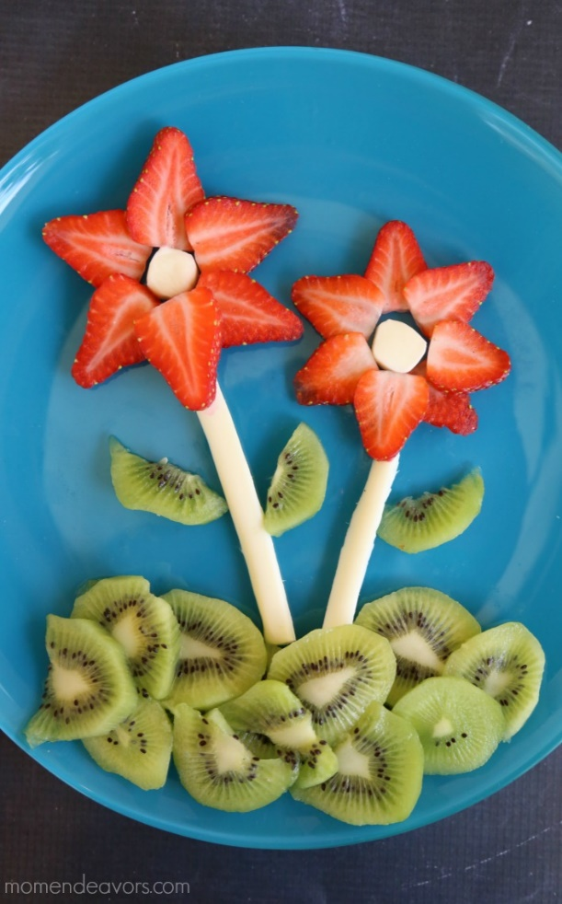
2 String Cheese Cheese Slices
Kiwi Grapes
Strawberries Celery
2 Mini Marshmallows

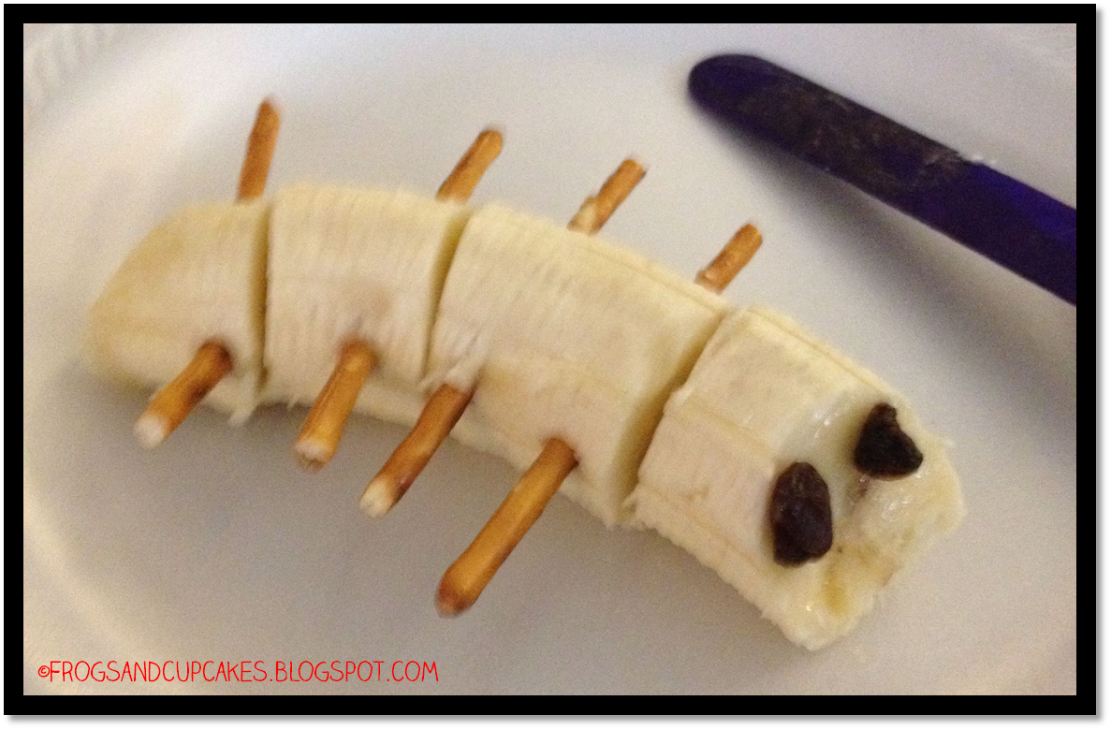
½ Banana
4 Pretzel sticks
2 Raisins

 Per Linda, CACFP, the above are credible as snacks.
House Plants

The air inside our homes can become more toxic than the air outdoors especially during the winter. Those that have air conditioning, this also includes the summer months. Naturally we close our homes up. The use of plants are a natural way to clean air inside our homes. Also, plants help create interesting spaces within our walls.

 English Ivy  Bamboo Palms
Corn Plants

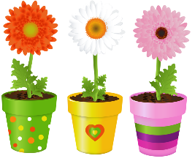 Gerbera Daisies



Reminder: Be sure to check for possible allergies a child may have.
Use only non-poison plants around children and pets.




Knock Knock
Who’s there?
June.
June who?
June know any good jokes?




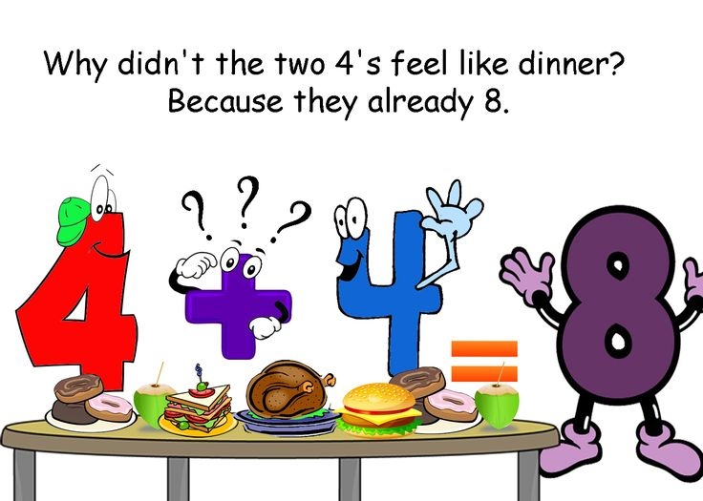


How To Get a Toddler To Listen
By, Deborah Cruz
If you’ve known a toddler, you know that good listening is not a skill they’re born with. Like walking, talking, and crawling, listening skills are something that we need to teach, encourage, and positively reinforce. Knowing how to get a toddler to listen is about as easy as herding cats.
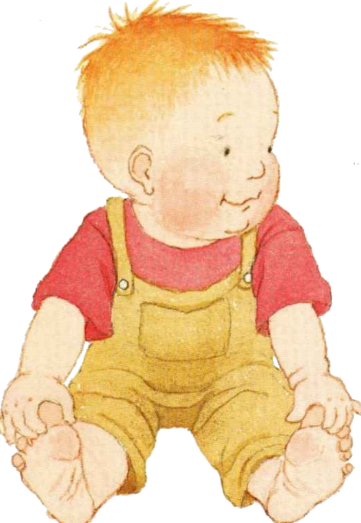
Little children are easily distracted. It’s not that they don’t want to listen,
but other things are more interesting, especially a screen.

Tips and tricks to get a toddler to listen

Resist the urge to repeat yourself
No one wants to spend their child’s toddlerhood exasperated or nagging. It’s negative attention that sends the wrong message. I’ve always tried to reward my girls with positive attention for listening rather than admonishing them for not. There are things we can do to avoid repeating ourselves to get our little ones to become better listeners.
Get down on their level
Don’t yell from another room. If you want them to listen, establish eye contact. Bend or squat down and get her attention by engaging face to face. This eye to eye contact establishes a direct connection. Your child is more likely to listen and feel accountable. “I used to tell my son that I had a secret, get down on his level, and whisper, ‘I love you’, it always worked,” mom Bertha Tuskan told Mom.com.


Read to them
Reading out loud to your toddler is perfect for helping them learn to listen. My girls used to be enthralled and lean in to hear every word that I said when reading Mrs. McNosh Does the Wash. I read with voices and sound effects. It truly makes a difference in engagement. Those voices make the words stand out.

Also, read new stories because once they know the story, they don’t need to be as attentive to hear what you are saying because they know what’s coming next. If it’s a new book, they need to pay attention. Also, whisper when you read some of the story. They’ll really have to put on their listening ears to know what’s going on.
Keep your voice down
Yelling is not the solution for toddlers or for parents. “Get quieter, not louder. Getting louder makes your blood pressure go up and makes you feel more unhappy or angry“, Dr. Deborah Gilboa told Mom.com. “Everyone listens better when it sounds like a secret. We get quieter ourselves and pay attention better. Toddlers are the same. Getting louder trains your toddler that they don’t need to listen until you’re yelling.”
Enunciate
Tell them what you want as clearly and concisely as you can. Don’t ask, tell. Don’t say, “Can you pick up your toys?” but instead, “Pick up your toys, please.” There is no choice, don’t pretend there is. Nagging won’t work. Explanations won’t work with toddlers. You can offer a reward for listening the first time. This teaches your toddler that listening to you has its benefits.
Positive reinforcement
Toddlers are easily distracted and completely enthralled by screens. If you tell them that it’s dinner time and they are watching cartoons, you may need to give a visual cue by pausing the show, walking over to them, and putting your hand on their back or physically walking them to the dinner table.

Follow through when your toddler still won’t listen
Sometimes, even with all of the suggestions we’ve laid out here, your toddler still won’t listen. So, if you find yourself telling your toddler to do something and they don’t do it, don’t make empty threats. You’ll lose all of your parental credibility. Same goes with promises. Don’t make empty promises. You’ll lose their trust. Try to mean what you say and follow through. Don’t buckle in the midst of tantrums or puppy dog eyes. Follow through quickly with consequences. Try not to repeat yourself. Hopefully, this will condition them to listen the first time.

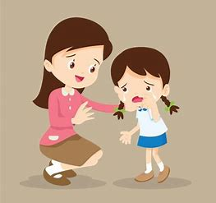

Inspire good listening skills
Motivate your children to be good listeners. Yelling might get their attention and startle them momentarily into listening, but this is not sustainable. Most toddlers will get upset and then you’ve got a 2-foot-tall loose cannon. Nobody wants that. Toddlers, like most human beings, respond better to a good attitude and positivity.
My girls used to hate to wake up and would ignore me. I started singing the “Good Morning” song from Singing in the Rain, with some altered lyrics, silly dancing and funny voice. They loved it and were caught up so much in my performance that they listened and got up every morning with a smile. It’s weird, but it worked.
If you want your toddler to listen, listen to them. They see and hear everything we do, especially when we’re not paying attention. When you’re talking with your spouse, friends, or even your toddler, look them in the eye, be respectful, and let them finish their thoughts. Don’t talk over people and respond politely to people when they talk to you.

Flower: suckers, cupcake wrappers, smaller candy wrappers
(Be sure to change leaf to Happy Mother’s Day)

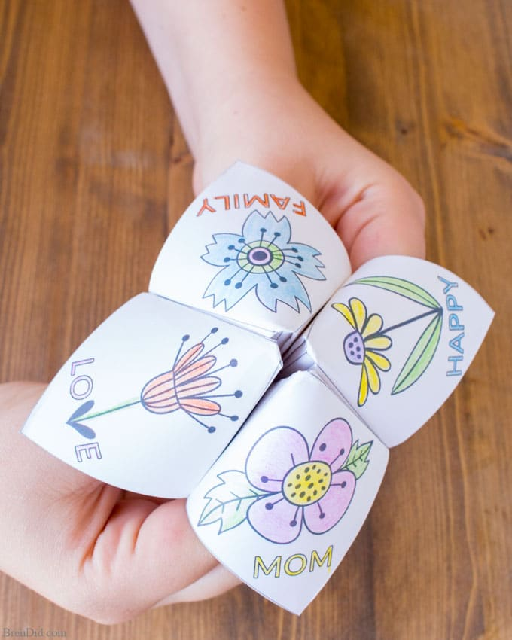
Paper and crayons or colored pencils

Per Warren Buffett

This is the biggest mistake made when teaching kids about money.
By, Tom Popomaronis

If there's one person who understands the importance of teaching kids about financial responsibility, it's Warren Buffett.
Before he became CEO of Berkshire Hathaway, the legendary investor started a handful of small businesses starting at age six, when he purchased a six-pack of Coke for 25 cents and sold each can for a nickel. He also sold magazines and gum from door to door.
"My dad was my greatest inspiration," Buffett said in an interview with CNBC back in 2013. "What I learned at an early age from him was to have the right habits early. Savings was an important lesson he taught."
When asked what he thinks is the biggest mistake parents make when teaching their kids about money, the billionaire said, "Sometimes parents wait until their kids are in their teens before they start talking about managing money when they could be starting when their kids are in preschool."

Time is a factor:
Yes, you read that right: Preschool. To Buffett's point, researchers have noted that 80% of our brain growth happens by age 3.
One Cambridge University study called "Habit Formation and Learning in Young Children" found that kids are already able to grasp basic money concepts between the ages of 3 and 4. And by age 7, basic concepts relating to future financial behaviors will typically have developed.
"Most parents already know how important it is to teach their kids about money and how to managing it properly," Buffett acknowledged. But there's a difference between knowing and taking action.
According to a 2018 survey from T. Rowe Price, which gathered responses from 1,014 parents of children between the ages of 8 to 14 and more than 1,000 young adults, ages 18 to 24, only 4% of parents said they started discussing financial topics with their kids before the age of 5.
Thirty percent of parents started educating their kids about money at age 15 or older, while 14% said they "never" did at all.

Lessons Buffett taught his own kids:
In 2011, Buffett helped launch a children's animated series called "Secret Millionaire's Club," which features himself as a mentor to a group of students.
The show has 26 episodes, and each one tackles a financial lesson, such as how a credit card works or why it's important to understand where you put your money.
"I taught all three of my kids the lessons taught in 'Secret Millionaires Club,'" Buffett told CNBC. "They are simple lessons meant for business and for life."

Here are a few lessons from the show,
along with tips from Buffett on how to teach them to your kids:
1. How to be a flexible thinker:
The goal of this lesson encourage your kids not to give up just because something doesn't work the first time. The ability to think creatively and outside the box will come in handy when they run into future financial challenges.
Activity ideas:
- Go to an art museum with your kids and discuss the different styles of each painting. Then, invite them to paint something of their own. Have them brainstorm different tools besides the paintbrush that can be used e.g., sponges, cotton swabs, fingers.
- Turn your trash into treasure by challenging your kids to come up with new uses for old things around the house (e.g., bottle caps can double as checker pieces, an empty cereal box can be turned into a magazine holder). This will help teach them how to think critically, save money, and help the environment all at the same time.
2. How to start saving money:
As Ben Franklin once said, "A penny saved is a penny earned." To help your kids learn to manage their money, it's important for them to understand the difference between wants and needs.
Activity ideas:
- Give each of your children two money jars: One for savings and one for spending. Each time they receive money (e.g., as a gift, for allowance, for walking the neighbor's dog), talk to them about how they wish to split the money between savings and spending.
- Have your kids make a list or create a collage from magazine photos of five to ten things they'd like to purchase. Then, go through each item with them and mark whether it's a want or a need e.g., a new toy is a want, while a new backpack is a need.

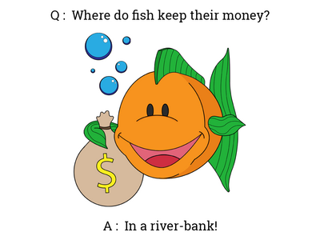

3. How to differentiate between price and value:
We've all been guilty of paying more money for a cool brand of shoes or gadget when we could have gotten a similar item that was just as good for a lesser price.
The idea behind this lesson is to help kids understand the different ways advertisers get us to buy their services or products, as well as how to tell what is and what isn't worth paying for.
Activity ideas:
- Make a list of items you need at the supermarket. Then check flyers, newspapers and websites with your kids for items on the list that may be on sale. Compare those prices and see which store offers the best deal for a specific product.
- Pick up a magazine with your kids and choose an ad to evaluate. Ask them: What's being sold? What message is the ad trying to get across? What catches their attention in the ad? How does the ad make them feel? How is it trying to persuade them to buy the product?
4. How to make good decisions:
The key to making smart decisions is to think about how different choices can impact future outcomes.
Activity ideas:
- Buffett suggests modeling good decision-making skills and talking to your kids about them. He also suggests discussing any resulting domino effect they could have. For example: "We want to buy a new TV, but our AC is broken and we need to save money to get it fixed. If we don't, it will be too hot in the house when summer comes around. Once the AC is repaired, we can think about buying the TV."
- Get your kids in the habit of making good decisions about how to save money. Maybe there's a DVD they want to buy. Ask them whether they really need it or if they can rent the movie from the library.

'It's never too early'
Instilling healthy financial habits in your kids is one of the most important things you can do to help ensure they have a successful future.
"It's never too early," Buffett said in a Q&A with Yahoo Finance in 2013. "Whether it's teaching kids the value of a dollar, the difference between needs and wants, or the value of saving these are all concepts that kids encounter at a very early age. So it's best to help them to understand it."


http://smckids.com/episodes/
Tom Popomaronis is a commerce expert and proud Baltimore native. Currently, he is the Senior Director of Product Innovation at the Hawkins Group. His work has been featured in Forbes, Fast Company and The Washington Post. In 2014, he was named one of the "40 Under 40" by the Baltimore Business Journal.
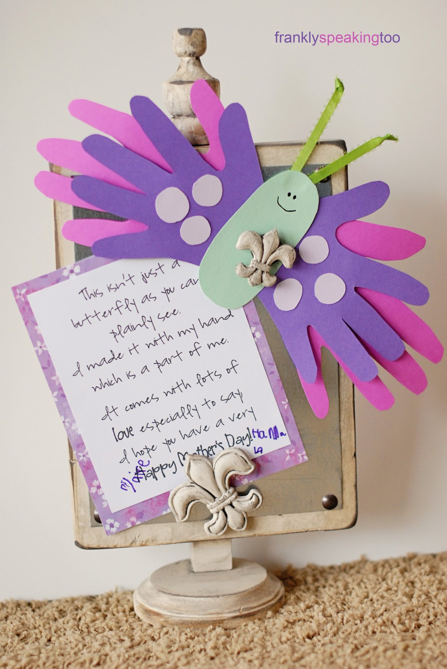
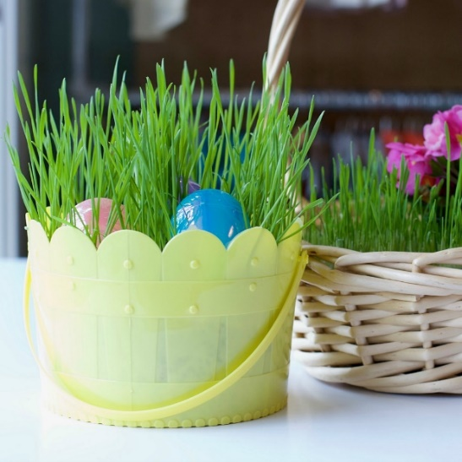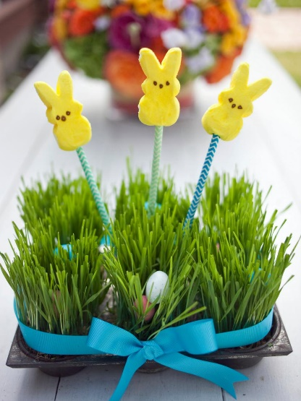

Grow a Living Easter Basket

Needed:
◊ Planting Container: A plastic or galvanized bucket or a muffin tin. Use a container with a wide opening so Easter goodies may be placed easily and grass has enough surface area to grab sunlight and grow, grow, grow!
◊ Wheat or any fast growing grass seed.
◊ All-purpose potting soil mixture.
◊ Water

Grow a Living Easter Basket:
Springtime brings so many moments to savor in nature: blue skies, chirping birds, gentle rain and bursting blossoms in every neighbor's garden bed. For extra springtime enjoyment, grow a living Easter basket.

This easy to create living Easter basket makes a perfect kids craft and is a lot of fun to watch grow over a short week of sunlight near a picture window. Your little bunnies will love planting their wheat grass seeds, watering their basket, and waiting just a few days to watch the seeds germinate.

Find a window in your home and set the baskets there to germinate and grow.
You are welcome to trim your grass if it grows beyond your needs and have fun with the process!

IDEA:

If you would like to add a small potted plant into your large sized basket, push a LARGE mason jar into the potting medium to create a 'cavity' that you can use for your small potted plant (4" pot). Once your grass seeds start to germinate, pull the Mason jar from the soil and replace it with your small potted plant.

Sprinkle wheat grass seeds on top of your potting medium.

Be sure to give your creation a nice drink of water, then set the basket next to a window for indirect lighting.

Approximately 4 days later the grass will start to germinate and a week after that you'll have a full basket of grass.

Your basket doesn’t need to be watered as the potting medium retains water very well. If you decide to add a little potted plant, please do water this.



Here are some tips on how to keep bath time safe for infants and toddlers. https://www.healthychildren.org/English/safety-prevention/at-home/Pages/Bathroom-Safety.aspx



Simple Tips to Childproof Your Bathroom & Prevent Injuries
Supervision: Children can drown in only a few inches of water, so never leave a young child alone in the bath, even for a moment. If you can't ignore the doorbell or the phone, wrap your child in a towel and take him along when you go to answer them. Bath seats and rings are meant to be bathing aids, but will not prevent drowning if the child is left unattended. Never leave water in the bathtub when it is not in use. It's also important to have anything and everything you think you'll need within arm's reach before​ getting down to business. See Preparing Your Baby's Bathing Area for a list of supplies.

Slips and falls: Install no-slip strips on the bottom of the bathtub. Put a cushioned cover over the water faucet so your child won't be hurt if he bumps his head against it. Get in the habit of closing the lid of the toilet, and get a toilet lid lock. A curious toddler who tries to play in the water can lose his balance and fall in.

Water temperature: To prevent scalding, adjust your water heater so the hottest temperature at the faucet is no more than 120 degrees Fahrenheit (48.9 degrees Celsius). Test the water with your wrist or elbow to check that it feels warm, not hot. When your child is old enough to turn the faucets, teach him to start the cold water before the hot.

Medicine and toiletry storage: Keep all medicines in containers with safety caps. Remember these caps are child-resistant, not childproof, so store all medicines and cosmetics high and out of reach in a locked cabinet. Don't keep toothpaste, soaps, shampoos, and other frequently used items in the same cabinet. Instead, store them in a hard-to-reach cabinet equipped with a safety latch or locks.

Electric appliances: If you use electrical appliances in the bathroom, particularly hair dryers and razors, be sure to unplug them and store them in a cabinet with a safety lock when they aren't in use. It is better to use them in another room where there is no water. An electrician can install special bathroom wall sockets (ground-fault circuit interrupters) that can lessen the likelihood of electrical injury when an appliance falls into the sink or bathwater.

 Rubber Duckies have been around since the 1940s. They aren’t just fun at bath time. Check out this list of 25 fun activities with rubber duckies. Be sure your rubber ducky is made from non-toxic materials!

https://www.naeyc.org/resources/pubs/tyc/apr2015/25-things-do-rubber-ducks 

Provider Trainings
For more information, please check your January – April 2020 Training Calendar

JUST A REMINDER: All child care providers are required to take 30 hours of training every 2 years.
DATE | TITLE | LOCATION
3/3/2020 | Child Abuse and Maltreatment & Abusive Head Trauma (AHT) | Community Child Care Clearinghouse of Niagara
3/7/2020 | CPR & First Aid | Mount St. Mary’s Child Care Center
3/9/2020 | Safety Supervision and Security | Community Child Care Clearinghouse of Niagara
3/21/2020 | Medication Administration Training (MAT) | Mount St. Mary’s Child Care Center
3/23/2020 | Behavior Management – Part I | Community Child Care Clearinghouse of Niagara
3/25/2020 | Child & Adult Care Food Program (CACFP) | Community Child Care Clearinghouse of Niagara
4/4/2020 | CPR & First Aid | Mount St. Mary’s Child Care Center
4/7/2020 | Child Abuse and Maltreatment & Abusive Head Trauma (AHT) | Community Child Care Clearinghouse of Niagara
4/16/2020 | Behavior Management – Part II | Community Child Care Clearinghouse of Niagara
4/25/2020 | Medication Administration Training (MAT) | Mount St. Mary’s Child Care Center
4/27/2020 | Safety Supervision and Security | Community Child Care Clearinghouse of Niagara
A minimum of five (5) hours of Office approved training must be obtained EACH YEAR.

New York State Office of Children and Family Services (OCFS) Free On-Line Trainings:
http://www.ecetp.pdp.albany.edu/elearncatalog.shtm

Prevention and Identification of Brain Injuries, including Abusive Head Trauma (AHT) **NEW**
OCFS Training Topics 7, 4, 1, 6, 8, & 9 (2.0 training hours)
Managing Challenging Behavior: Birth to 18 Months
OCFS Training Topic 1 (1.5 training hours)
Managing Challenging Behavior: 18 Months to 36 Months
OCFS Training Topic 1 (1.5 Training hours)
Keeping Children Safe: Prevention of Lead Poisoning and Other Dangers to Children
OCFS Training Topics 1, 3, 4 & 7 (1.5 training hours)
Preventing Sudden Infant Death Syndrome & Promoting Safe Sleeping
OCFS Training Topics 1, 3, 4 & 7 (1.0 training hours)
Foundations in Health & Safety OCFS Training Topics 2, 3, 4, 7, 8 & 9 (5 training hours)
Expulsion & Suspension Prevention Strategies OCFS Training Topics 1, 3, & 4 (1.5 training hours)
Infant Brain Development OCFS Training Topics 1 & 3 (1 training Hour)
School Age Child Care OCFS Training Topics 1, 3 & 4 (1.5 training hours)
Supervision of Children OCFS Training Topic 4 (1.5 training hours)
Obesity Prevention OCFS Training Topic 2 (2.0 training hours)
Emergency Preparedness OCFS Training Topics 4 & 7 (1.5 training hours)
Family Engagement OCFS Training Topics 3 & 4 (1.0 training hours)
Early Intervention OCFS Training Topics 1 & 4 (1.5 training hours)
Transportation OCFS Training Topics 3, 4 & 7 (2.0 training hours)
Mandated Reporter On-Line Training OCFS Training Topics 5, 6, & 8 (2.0 training hours)
Niagara Community Action  Board of Directors:  Tim Beach Thomas Beachy  Andrea Haseley Andrew Kirsch  John Lombardi III Kimberlyann Meal  Robert Pecoraro Ann Printup  James Pyra Joyce Scott  Danny Sklarski Dennis Stachera  Owen Steed Pamela Stevenson  Charles Walker  CCR&R Staff:  Supervisor: Angela Burns  Registrar Unit: Kimmarie Brown  Elizabeth Nowakowski  Patrick Carr  Technical Assistant  Specialist: Beverly McArthur  Infant & Toddler  Technical Specialist: Kelly Janese  Legally Exempt: Debbie Perricelli  Donna Striffler  CC Referrals: Carolyn Jacobs  CACFP: Linda Newman  Betty McCarthy  Mission Statement:  Niagara Community Action Program, Inc. is a countywide agency dedicated to reducing poverty in a collaborative effort by initiating and conducting programs of self-sufficiency. Our ultimate goal is to empower individuals and families to reach their fullest potential.  Office Closings:  • Good Friday April 10, 2020  • Memorial Day May 25, 2020  Contact Information:  Community Child Care  Clearinghouse of Niagara  1521 Main Street  Niagara Falls, NY 14305  Phone: 716-285-8572  Toll Free: 1-800-701-4KID (4543)  Fax: 716-286-9243  E-mail: ccrrniagara@niagaracap.org  Web: www.childcareofniagara.com  Facebook:  https://www.facebook.com/CCRandR/ | 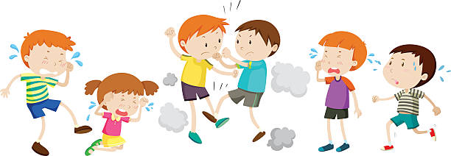  Do you have a screaming child, a disgruntled parent, or a curriculum which isn’t working for you?  This is just a sample of the problems you may face as a child care provider. If you would like help with these issues in your day care, contact either Beverly McArthur (children aged 3 to 12 years) or Kelly Janese (children aged 6 weeks up to 3 years).  This may include: Observations Trainings Assessments  Quality Improvement Plan Other technical support  To make an appointment with:  Beverly 716-285-8572 ext. 115  (children aged 3 to 12 years)  Kelly 716-285-8572 ext. 104  (children aged 6 weeks up to 3 years)   Child & Adult Care Food Program (CACFP)  CACFP is a nutrition education and meal reimbursement program to help providers serve nutritious and safely prepared meals and snacks to children in day care settings. The income from his program is tax free.  For more information call: Betty McCarthy  716-285-9681 ext. 111  This institution is an Equal Opportunity Provider (EOE).  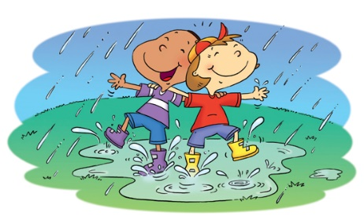  Puddle Splash!  During a warm afternoon rain, go splashing!  There isn’t a child, or child at heart, that wouldn’t have a fantastic time. Plus kids just might think you’re a bit crazy! So why leave any room for doubt? Go for it!!!

