
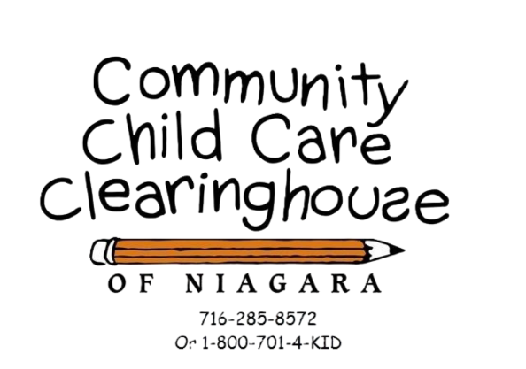

Training Calendar
April – June
2026

1521 Main Street,
Niagara Falls, N.Y. 14305
ANNOUNCEMENTS

Office of Children and Family Services (OCFS)
Sponsored Online Training: Foundations in Health and Safety
https://www.ecetp.pdp.albany.edu/elearn_catalog.shtm
NOTE: If you took this course previously, it is not necessary to view the video again.
REMINDER: Every provider, director, teacher, and/or volunteer with the potential for regular and substantial contact with children in care must complete the office-approved training pre-service within 3 months of beginning employment.
This FREE, fully narrated 5-hour e-learning course offers important information and strategies to facilitate and improve the safety and health of children in regulated child care programs and enrolled legally exempt programs. Child care providers and caregivers completing this course will receive training credit in federally mandated health and safety topic areas which include:
- Prevention and control of infectious diseases including immunizations.
- Prevention of sudden infant death syndrome and use of safe sleeping practices.
- Administration of medication consistent with standards for parental consent.
- Prevention and response to emergencies due to food and allergic reactions.
- Building and physical premises safety, including identification of and protection from hazards that can cause bodily injury such as electrical hazards, bodies of water, and vehicular traffic.
- Prevention of Abusive Head Trauma (AHT) formerly shaken baby syndrome.
- Emergency preparedness and response planning for emergencies resulting from a natural disaster or a man-caused event.
- Handling and storage of hazardous materials and the appropriate disposal of bio-contaminants.
- Appropriate precautions transporting children, if applicable.
- Pediatric first-aid and cardiopulmonary resuscitation (CPR).
- Other requirements relating to nutrition, access to physical activity, or any other subject area necessary to promote child development or to protect children’s health and safety.
Training learning points are enhanced by using video clips and interactive exercise.
Child care providers can participate in this 5-hour web-based online training course at any time, 24 hours a day, and seven days a week.
As you complete each 10–15-minute section, the application saves your progress and allows you up to 30 days to complete the entire course.
- The self-directed online course “Foundations in Health and Safety e-Learning” fulfills OCFS training requirements.
- Nutrition and health needs of infants and children.
- Child day care program development.
- Safety and security procedures.
- Child abuse and maltreatment identification and prevention.
- Statutes and regulations pertaining to child day care.
- Education and information on the identification, diagnosis and prevention of shaken baby syndrome.
Revised 02/23/26

COMMUNITY CHILD CARE CLEARINGHOUSE OF NIAGARA
TRAINING CLASS POLICIES

- Registration and payment prior to the date of the training class is mandatory.
- The number of required registrations must be received, complete with payment (or notification of registration and proof of payment) prior to the date of the class or the class will be cancelled.
- The Community Child Care Clearinghouse of Niagara reserves the right to cancel scheduled child care training when necessary. Payment will be refunded.
- Cash, checks and money orders are accepted for training (please make payable to Niagara Community Action Program, Inc.)
- A $45.00 fee will be required for returned checks.
- Training class fees are non-refundable.
- If payment is made with an Educational Incentive Program (EIP) Award, it must be received prior to the training or the provider must pay with cash, money order or check made out to Niagara Community Action Program, Inc. The Community Child Care Clearinghouse of Niagara will reimburse participants for EIP awards submitted following training classes, provided applications for reimbursement are submitted within the time limits as required by the EIP program. For EIP information and application, see the last 3 pages of this training calendar.
- If payment is made with a coupon, the coupon must accompany the registration form. Coupons must be for the full cost of the class or supplemented by check, cash or money order. The coupon must have a non-expired date.
- Family/Group Family and Legally Exempt providers may use CSEA/VOICE funds for their CPR/First-aid training. Visit https://voicecsea.org/training/ for more information.
- Participants arriving late for training classes will not be admitted.
- Training class fees will not be refunded to late arrivals.
- Upon request, training database records will be given to the provider or to representatives of the New York State Office of Children and Family Services.
- For training at a child care facility or to bring a program into compliance with a corrective action plan, there will be a set fee, per class, charged by the Community Child Care Clearinghouse of Niagara to train child care employees. This fee is non-refundable and non-transferrable. Payment or proof of payment must be received one week prior to the training. Cash, checks and money orders are accepted for training (please make payable to Niagara Community Action Program, Inc.)


Revised 02/23/26

TRAINING REQUIREMENTS
http://www.childcareofniagara.com/

The regulations of the New York State Office of Children and Family Services require all child care providers to have thirty (30) hours of training every two years.
A minimum of five (5) hours of office approved training must be obtained each year.
This training must address the following topics:

- Principles of childhood development, including the appropriate supervision of children, meeting the needs of children enrolled in the program with physical or emotional challenges, and behavior management and discipline.

- Nutrition and health needs of children.

- Child day care program development.

- Safety and security procedures including communication between parents and staff.

- Business record maintenance and management.

- Child abuse and maltreatment identification and prevention.

- Statutes and regulations pertaining to child day care.

- Statutes and regulations pertaining to child abuse and maltreatment.

- Education and information on the identification, diagnosis and prevention of Abusive Head Trauma (AHT) formerly Shaken Baby Syndrome.

- Adverse Childhood Experiences (ACES) **

** On December 17, 2020, legislation was signed which requires all child care providers in New York State to receive training about Adverse Childhood Experiences (ACEs). **

Revised 02/27/25

Professional Development
and
Customized Training Opportunities

At Community Child Care Clearinghouse of Niagara, we are committed to supporting your program with high-quality professional development opportunities.
If there is a specific training you need and do not see it listed, we are happy to develop a customized training course to meet your needs.
If attending a training at our site is not convenient, we can bring the training to your program for a fee.
Additionally, we offer discounted rates for multiple training courses scheduled for the same professional development day.
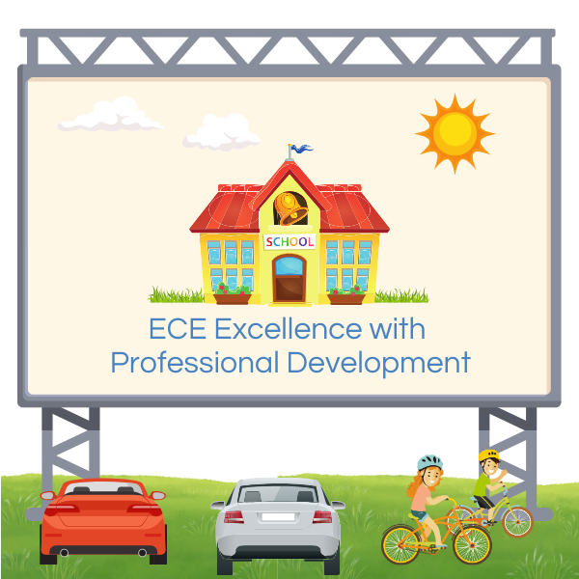
Please let us know how we can best support your team’s training needs.

Revised 02/27/25
Training Calendar
April 2026
Please note the location & time of training when registering.

Thursday, April 02, 2026 | Child Care Program Marketing
Thursday, April 02, 2026 | This training will help you understand the foundation of creating an effective marketing plan. We will explore how the seven P’s of marketing apply to your program, work on developing a clear marketing position statement, and create a strong value proposition statement to highlight the benefits of your program.
Thursday, April 02, 2026 | Location: Community Child Care Clearinghouse of Niagara  - 1521 Main St, Niagara Falls, NY 14305  Trainer: Donna Striffler  Time: 6:00 PM to 9:00 PM  Cost: Free
Thursday, April 02, 2026 | OCFS Training topics: 3, & 5 (3 training hours)  This training is for: FDC, GFDC, DCC & SACC providers

Saturday, April 04, 2026 | First-Aid / CPR / AED  (Automated External Defibrillator)
Saturday, April 04, 2026 | Participants completing this training will receive a two-year certificate in infant, child & adult CPR and pediatric first-aid. Training will include:  - Simulated rescue breathing techniques  - Directions on what to do in a choking situation  - Instruction in basic first-aid
Saturday, April 04, 2026 | Location: Mount St. Mary’s Child Care Center - …………...5310 Military Road, Lewiston, NY 14092  Trainer: Heather Bennett  Time: 8:30 AM to 1:00 PM  Cost: $100 (payable through EIP & VOICE/CSEA eligible participants)
Saturday, April 04, 2026 | OCFS Training topics: 2 & 4 (4 training hours)  This training is for: FDC, GFDC, DCC & SACC providers  ** Scholarship funding to participate in this training may be available through the Educational Incentive Program (EIP).  For more information or to apply for a scholarship, please visit https://www.ecetp.pdp.albany.edu/index.aspx You may also contact EIP by email at eip-to-@albany.edu or call: (800) 295-9616 or (518) 442-6575

Tuesday, April 07, 2026 | Shaken Baby Syndrome
Tuesday, April 07, 2026 | This comprehensive training on Shaken Baby Syndrome offers vital education for anyone who cares for or works with infants. Participants will gain a clear understanding of what Shaken Baby Syndrome is, why it occurs, and the devastating effects it can have on a child’s health and development. The course covers how to recognize warning signs, respond appropriately in suspected cases, and, most importantly, prevent such incidents through safe caregiving practices and stress management techniques. With engaging lessons, real-life examples, and interactive tools, this course empowers caregivers, parents, and professionals to protect infants and promote safer environments.
Tuesday, April 07, 2026 | Location: Community Child Care Clearinghouse of Niagara  - 1521 Main St, Niagara Falls, NY 14305  Trainer: Chrissy Parfinski & Donna Striffler  Time: 6:00 PM to 8:00 PM  Cost: Free
Tuesday, April 07, 2026 | OCFS Training topics: 1, 3, & 4 (2 training hours)  This training is for: FDC, GFDC, & DCC providers

Monday, April 13, 2026 | Autism: It’s Not What You Think
Monday, April 13, 2026 | We all have ideas about what autism is and what characteristics and behaviors might constitute a diagnosis. The truth is as much as we know about the children in our care, we really don’t know that much about autism. Without very specific training and coursework, we are left with what we see in the media, and a lot of it is not accurate.  In this presentation/conversation, we will delve into the myths and misunderstandings to learn more about autism and gain insight into what it actually is. We will also discuss neurodiversity, sensory processing and some basic behavior management tools to help support you in your program or at home
Monday, April 13, 2026 | Location: Community Child Care Clearinghouse of Niagara  - 1521 Main St, Niagara Falls, NY 14305  Trainer: Erin Crump  Time: 6:00 PM to 8:00 PM  Cost: Free
Monday, April 13, 2026 | OCFS Training topics: 1 & 3 (2 training hours)  This training is for: FDC, GFDC, & DCC providers

  Thursday, April 16, 2026 | Cultivating Awareness in Early Childhood
This interactive two-hour training is designed for childcare providers, early childhood educators, and administrators who are committed to creating inclusive and equitable learning environments. Participants will explore the concept of perspectives and assumptions, and how cultural, behavioral, and special needs–related assumptions can impact children’s development and classroom experiences.
Through case studies, role-playing, classroom material reviews, and self-reflection activities, participants will learn practical strategies to foster cultural awareness, implement gender-neutral and equitable discipline practices, and ensure meaningful inclusion for children of all abilities. The training also focuses on building self-awareness, recognizing implicit influences, and developing ongoing cultural competency.
Participants will leave with a personalized action plan to strengthen inclusive practices within their programs. A certificate of completion will be provided upon active participation and completion of course requirements.
Location: Community Child Care Clearinghouse of Niagara
- 1521 Main St, Niagara Falls, NY 14305
Trainer: Donna Striffler & Chrissy Parfinski
Time: 6:00 PM to 8:00 PM
Cost: Free
OCFS Training topics: 1, 3, & 4 (2 training hours)
This training is for: FDC, GFDC, DCC & SACC providers

Tuesday, April 21, 2026 | The Importance of Child-Led Art
Tuesday, April 21, 2026 | By the end of this 2-hour training, participants will be able to define child-led art, distinguish it from teacher-directed crafts, and understand its benefits for children's development. You will learn best practices for implementing child-led art in the classroom, develop strategies to encourage creativity and independence, and discuss common challenges and solutions. Come ready to have fun and maybe get a little messy!
Tuesday, April 21, 2026 | Location: Community Child Care Clearinghouse of Niagara  - 1521 Main St, Niagara Falls, NY 14305  Trainer: Donna Striffler & Chrissy Parfinski  Time: 6:00 PM to 8:00 PM  Cost: Free
Tuesday, April 21, 2026 | OCFS Training topics: 1 & 3 (2 training hours)  This training is for: FDC, GFDC, DCC & SACC providers
Tuesday, April 28, 2026 | Supporting Children with Challenging Behaviors in Early Childhood Education
Tuesday, April 28, 2026 | This course is designed to equip early childhood educators and caregivers with the knowledge and tools to effectively support children with challenging behaviors effectively. Participants will learn to identify underlying causes behind these behaviors, implement positive behavior strategies to guide children, collaborate with families and specialists, and manage stress as professionals.
Tuesday, April 28, 2026 | Location: Community Child Care Clearinghouse of Niagara  - 1521 Main St, Niagara Falls, NY 14305  Trainer: Donna Striffler & Chrissy Parfinski  Time: 6:00 PM to 8:00 PM  Cost: Free
Tuesday, April 28, 2026 | OCFS Training topics: 1, 4, 5, & 7 (2 training hours)  This training is for: FDC, GFDC, DCC & SACC providers

Training Calendar
May 2026
Please note the location & time of training when registering.

Saturday, May 02, 2026 | First-Aid / CPR / AED  (Automated External Defibrillator)
Saturday, May 02, 2026 | Participants completing this training will receive a two-year certificate in infant, child & adult CPR and pediatric first-aid. Training will include:  - Simulated rescue breathing techniques  - Directions on what to do in a choking situation  - Instruction in basic first-aid
Saturday, May 02, 2026 | Location: Mount St. Mary’s Child Care Center - …………...5310 Military Road, Lewiston, NY 14092  Trainer: Heather Bennett  Time: 8:30 AM to 1:00 PM  Cost: $100 (payable through EIP & VOICE/CSEA eligible participants)
Saturday, May 02, 2026 | OCFS Training topics: 2 & 4 (4 training hours)  This training is for: FDC, GFDC, DCC & SACC providers  ** Scholarship funding to participate in this training may be available through the Educational Incentive Program (EIP).  For more information or to apply for a scholarship, please visit https://www.ecetp.pdp.albany.edu/index.aspx You may also contact EIP by email at eip-to-@albany.edu or call: (800) 295-9616 or (518) 442-6575

Wednesday, May 06, 2026 | Closing the Gaps: Preventing Health & Safety Violations in Early Childhood Programs (Infant & Toddlers)
Wednesday, May 06, 2026 | This interactive training provides early childhood educators and program staff with an in-depth overview of safety, health, and infection control standards within OCFS regulations. Participants will explore common safety violations observed in child care programs and learn practical strategies to prevent risks, maintain compliance, and promote a healthy, secure environment for children.
Wednesday, May 06, 2026 | Location: Community Child Care Clearinghouse of Niagara  - 1521 Main St, Niagara Falls, NY 14305  Trainer: Stephanie Long  Time: 6:00 PM to 8:00 PM  Cost: Free
Wednesday, May 06, 2026 | OCFS Training topics: 1, 3, & 4 (2 training hours)  This training is for: FDC, GFDC, & DCC providers
Thursday, May 07, 2026 | Ongoing Financial Management
Thursday, May 07, 2026 | This training will use financial planning and management skills to sustain the program's operation. Providers will learn basic accounting terms that are needed for child care finances, identify common revenues for child care programs, and implement a system for financial record keeping procedures.
Thursday, May 07, 2026 | Location: Community Child Care Clearinghouse of Niagara  - 1521 Main St, Niagara Falls, NY 14305  Trainer: Donna Striffler  Time: 6:00 PM to 9:00 PM  Cost: Free
Thursday, May 07, 2026 | OCFS Training topics: 3, & 5 (3 training hours)  This training is for: FDC, GFDC, DCC & SACC providers

Tuesday, May 12, 2026 | Cultivating Awareness in Early Childhood
This interactive two-hour training is designed for childcare providers, early childhood educators, and administrators who are committed to creating inclusive and equitable learning environments. Participants will explore the concept of perspectives and assumptions, and how cultural, behavioral, and special needs–related assumptions can impact children’s development and classroom experiences.
Through case studies, role-playing, classroom material reviews, and self-reflection activities, participants will learn practical strategies to foster cultural awareness, implement gender-neutral and equitable discipline practices, and ensure meaningful inclusion for children of all abilities. The training also focuses on building self-awareness, recognizing implicit influences, and developing ongoing cultural competency.
Participants will leave with a personalized action plan to strengthen inclusive practices within their programs. A certificate of completion will be provided upon active participation and completion of course requirements.
Location: Community Child Care Clearinghouse of Niagara
- 1521 Main St, Niagara Falls, NY 14305
Trainer: Donna Striffler & Chrissy Parfinski
Time: 6:00 PM to 8:00 PM
Cost: Free
OCFS Training topics: 1, 3, & 4 (2 training hours)
This training is for: FDC, GFDC, DCC & SACC providers

Monday, May 18, 2026 | Autism: It’s Not What You Think
Monday, May 18, 2026 | We all have ideas about what autism is and what characteristics and behaviors might constitute a diagnosis. The truth is as much as we know about the children in our care, we really don’t know that much about autism. Without very specific training and coursework, we are left with what we see in the media, and a lot of it is not accurate.  In this presentation/conversation, we will delve into the myths and misunderstandings to learn more about autism and gain insight into what it actually is. We will also discuss neurodiversity, sensory processing and some basic behavior management tools to help support you in your program or at home
Monday, May 18, 2026 | Location: Community Child Care Clearinghouse of Niagara  - 1521 Main St, Niagara Falls, NY 14305  Trainer: Erin Crump  Time: 6:00 PM to 8:00 PM  Cost: Free
Monday, May 18, 2026 | OCFS Training topics: 1 & 3 (2 training hours)  This training is for: FDC, GFDC, & DCC providers
Saturday, May 23, 2026 | Medication Administration Training (MAT)
Saturday, May 23, 2026 | Child care providers who choose to administer medication to children must have a medication administration training (MAT) certificate, a current CPR and first-aid certificate and a health care consultant. Providers successfully completing this competency-based training will fulfill the requirement for the MAT certificate.
Saturday, May 23, 2026 | Location: Mount St. Mary’s Child Care Center - 5310 Military Road, Lewiston, NY 14092  Trainer: Teresa Kolodziej  Time: 8:30 AM to 4:30 PM  Cost: $240 – register online at: https://www.ecetp.pdp.albany.edu/
Saturday, May 23, 2026 | OCFS Training topics: 2, 4 & 7 (8 training hours)  This training is for: FDC, GFDC, DCC & SACC providers

Tuesday, May 26, 2026 | The Importance of Child-Led Art
Tuesday, May 26, 2026 | By the end of this 2-hour training, participants will be able to define child-led art, distinguish it from teacher-directed crafts, and understand its benefits for children's development. You will learn best practices for implementing child-led art in the classroom, develop strategies to encourage creativity and independence, and discuss common challenges and solutions. Come ready to have fun—and maybe get a little messy!
Tuesday, May 26, 2026 | Location: Community Child Care Clearinghouse of Niagara  - 1521 Main St, Niagara Falls, NY 14305  Trainer: Donna Striffler & Chrissy Parfinski  Time: 6:00 PM to 8:00 PM  Cost: Free
Tuesday, May 26, 2026 | OCFS Training topics: 1 & 3 (2 training hours)  This training is for: FDC, GFDC, DCC & SACC providers

Training Calendar
June 2026
Please note the location & time of training when registering.

Tuesday, June 02, 2026 | Struggling with Lesson Planning? Let’s Make It Easier!
Join us for a training on Lesson Planning in Early Childhood where we’ll break it down step by step. We will talk about how to write simple, measurable objectives, plan activities that actually support child development (not just cute crafts) and make lesson planning feel manageable instead of overwhelming.
This session is practical, interactive, and full of real classroom examples you can use right away. Whether you’re new to planning or just want to feel more confident, this training will help you plan with purpose and keep learning child-centered and meaningful.
Location: Community Child Care Clearinghouse of Niagara
- 1521 Main St, Niagara Falls, NY 14305
Trainer: Donna Striffler
Time: 6:00 PM to 8:00 PM
Cost: Free
OCFS Training topics: 1 & 3 (2 training hours)
This training is for: FDC, GFDC, DCC & SACC providers

Saturday, June 06, 2026 | First-Aid / CPR / AED  (Automated External Defibrillator)
Saturday, June 06, 2026 | Participants completing this training will receive a two-year certificate in infant, child & adult CPR and pediatric first-aid. Training will include:  - Simulated rescue breathing techniques  - Directions on what to do in a choking situation  - Instruction in basic first-aid
Saturday, June 06, 2026 | Location: Mount St. Mary’s Child Care Center - …………...5310 Military Road, Lewiston, NY 14092  Trainer: Heather Bennett  Time: 8:30 AM to 1:00 PM  Cost: $100 (payable through EIP & VOICE/CSEA eligible participants)
Saturday, June 06, 2026 | OCFS Training topics: 2 & 4 (4 training hours)  This training is for: FDC, GFDC, DCC & SACC providers  ** Scholarship funding to participate in this training may be available through the Educational Incentive Program (EIP).  For more information or to apply for a scholarship, please visit https://www.ecetp.pdp.albany.edu/index.aspx You may also contact EIP by email at eip-to-@albany.edu or call: (800) 295-9616 or (518) 442-6575

Tuesday, June 09, 2026 | The Importance of Child-Led Art
Tuesday, June 09, 2026 | By the end of this 2-hour training, participants will be able to define child-led art, distinguish it from teacher-directed crafts, and understand its benefits for children's development. You will learn best practices for implementing child-led art in the classroom, develop strategies to encourage creativity and independence, and discuss common challenges and solutions. Come ready to have fun—and maybe get a little messy!
Tuesday, June 09, 2026 | Location: Community Child Care Clearinghouse of Niagara  - 1521 Main St, Niagara Falls, NY 14305  Trainer: Donna Striffler & Chrissy Parfinski  Time: 6:00 PM to 8:00 PM  Cost: Free
Tuesday, June 09, 2026 | OCFS Training topics: 1 & 3 (2 training hours)  This training is for: FDC, GFDC, DCC & SACC providers

Wednesday, June 10, 2026 | Cultivating Awareness in Early Childhood
This interactive training is designed for childcare providers, early childhood educators, and administrators who are committed to creating inclusive and equitable learning environments. Participants will explore the concept of perspectives and assumptions, and how cultural, behavioral, and special needs–related assumptions can impact children’s development and classroom experiences.
Through case studies, role-playing, classroom material reviews, and self-reflection activities, participants will learn practical strategies to foster cultural awareness, implement gender-neutral and equitable discipline practices, and ensure meaningful inclusion for children of all abilities. The training also focuses on building self-awareness, recognizing implicit influences, and developing ongoing cultural competency.
Location: Community Child Care Clearinghouse of Niagara
- 1521 Main St, Niagara Falls, NY 14305
Trainer: Donna Striffler & Chrissy Parfinski
Time: 6:00 PM to 8:00 PM
Cost: Free
OCFS Training topics: 1, 3, & 4 (2 training hours)
This training is for: FDC, GFDC, DCC & SACC providers
Saturday, June 13, 2026 | Medication Administration Training (MAT)
Saturday, June 13, 2026 | Child care providers who choose to administer medication to children must have a medication administration training (MAT) certificate, a current CPR and first-aid certificate and a health care consultant. Providers successfully completing this competency-based training will fulfill the requirement for the MAT certificate.
Saturday, June 13, 2026 | Location: Mount St. Mary’s Child Care Center - 5310 Military Road, Lewiston, NY 14092  Trainer: Teresa Kolodziej  Time: 8:30 AM to 4:30 PM  Cost: $240 – register online at: https://www.ecetp.pdp.albany.edu/
Saturday, June 13, 2026 | OCFS Training topics: 2, 4 & 7 (8 training hours)  This training is for: FDC, GFDC, DCC & SACC providers

Monday, June 15, 2026 | Autism: It’s Not What You Think
Monday, June 15, 2026 | We all have ideas about what autism is and what characteristics and behaviors might constitute a diagnosis. The truth is as much as we know about the children in our care, we really don’t know that much about autism. Without very specific training and coursework, we are left with what we see in the media, and a lot of it is not accurate.  In this presentation/conversation, we will delve into the myths and misunderstandings to learn more about autism and gain insight into what it actually is. We will also discuss neurodiversity, sensory processing and some basic behavior management tools to help support you in your program or at home
Monday, June 15, 2026 | Location: Community Child Care Clearinghouse of Niagara  - 1521 Main St, Niagara Falls, NY 14305  Trainer: Erin Crump  Time: 6:00 PM to 8:00 PM  Cost: Free
Monday, June 15, 2026 | OCFS Training topics: 1 & 3 (2 training hours)  This training is for: FDC, GFDC, & DCC providers

Thursday, June 25, 2026 | Balancing the Iron Triangle: A Guide to Financial Sustainability in Early Childhood Education
Thursday, June 25, 2026 | This practical training introduces early childhood leaders to the Iron Triangle framework, developed by Louise Stoney, as a powerful “dashboard” for program financial health. Participants will explore the three interdependent sides of a sustainable childcare business: Full Enrollment, Full Fee Collection, and Revenue Covering Per-Child Cost.  Through real-world examples and actionable strategies, this session helps programs move from surviving to thriving by stabilizing cash flow, reducing bad debt, and understanding their true break-even point. Attendees will learn how to track occupancy rates, enforce effective tuition collection practices, and calculate the real cost of care to ensure long-term sustainability.  Participants will leave with a clear action plan to strengthen their financial foundation so they can focus on what matters most: delivering high-quality care to children and families.
Thursday, June 25, 2026 | Location: Community Child Care Clearinghouse of Niagara  - 1521 Main St, Niagara Falls, NY 14305  Trainer: Donna Striffler  Time: 6:00 PM to 8:00 PM  Cost: Free
Thursday, June 25, 2026 | OCFS Training topics: 1 & 3 (2 training hours)  This training is for: FDC, GFDC, DCC & SACC providers

Tuesday, June 30, 2026 | Conscious Discipline
Tuesday, June 30, 2026 | Come learn about Conscious Discipline, a way to help children manage their emotions and behaviors in a kind and caring way. This training will show you how to build stronger relationships, create safe spaces, and teach kids important life skills like calming down, making good choices, and getting along with others.
Tuesday, June 30, 2026 | Location: Community Child Care Clearinghouse of Niagara  - 1521 Main St, Niagara Falls, NY 14305  Trainer: Chrissy Parfinski & Donna Striffler  Time: 6:00 PM to 8:00 PM  Cost: Free
Tuesday, June 30, 2026 | OCFS Training topics: 1, 3, & 7 (2 training hours)  This training is for: FDC, GFDC, & DCC providers

April/May Training Registration Form
Name: _________________________________________________________ Phone: ___________________________
Address: _________________________________________________________________________________________
E-mail Address: ___________________________________________________________________________________
[ ] Family/Group Family Day Care [ ] Day Care Center [ ] School Age Child Care [ ] Legally Exempt

Name of Child Care Program: _______________________________________________________________________
Send your completed registration form along with a check or money order payable to
NIAGARA COMMUNITY ACTION PROGRAM, INC
Date & Time | Course Title | Location | Fee | Check if Attending
April 02, 2026 | Child Care Program Marketing | Community Child Care Clearinghouse of Niagara | FREE
April 04, 2026 | *First-Aid / CPR / AED  (Automated External Defibrillator) | Mt. St. Mary’s Child Care Ctr  5310 Military Rd, Lewiston, NY | $100
April 07, 2026 | Shaken Baby Syndrome | Community Child Care Clearinghouse of Niagara | FREE
April 12, 2026 | Autism: It’s Not What You Think | Community Child Care Clearinghouse of Niagara | FREE
April 16, 2026 | Cultivating Awareness in Early Childhood | Community Child Care Clearinghouse of Niagara | FREE
April 21, 2026 | The Importance of Child-Led Art | Community Child Care Clearinghouse of Niagara | FREE
April 28, 2026 | Supporting Children with Challenging Behaviors in Early Childhood Education | Community Child Care Clearinghouse of Niagara | FREE
May 02, 2026 | *First-Aid / CPR / AED  (Automated External Defibrillator) | Mt. St. Mary’s Child Care Ctr  5310 Military Rd, Lewiston, NY | $100
May 06, 2026 | Closing the Gaps: Preventing Health & Safety Violations in Early Childhood Programs | Community Child Care Clearinghouse of Niagara | FREE
May 07, 2026 | Ongoing Financial Management | Community Child Care Clearinghouse of Niagara | FREE
May 12, 2026 | Cultivating Awareness in Early Childhood | Community Child Care Clearinghouse of Niagara | FREE
May 18, 2026 | Autism: It’s Not What You Think | Community Child Care Clearinghouse of Niagara | FREE
May 23, 2026 | Medication Administration Training (MAT) | Mt. St. Mary’s Child Care Ctr  5310 Military Rd, Lewiston, NY | See prev. page  details
May 26, 2026 | The Importance of Child-Led Art | Community Child Care Clearinghouse of Niagara | FREE

June Training Registration Form
Name: _________________________________________________________ Phone: ___________________________
Address: _________________________________________________________________________________________
E-mail Address: ___________________________________________________________________________________
[ ] Family/Group Family Day Care [ ] Day Care Center [ ] School Age Child Care [ ] Legally Exempt

Name of Child Care Program: _______________________________________________________________________
Send your completed registration form along with a check or money order payable to
NIAGARA COMMUNITY ACTION PROGRAM, INC
NEW: For MAT training, register online at https://www.ecetp.pdp.albany.edu/ - Cost is $240, Scholarships are available to qualified participants, see the website – MAT tab for more details. Find the training dates under the trainer Teresa Kolodziej and pick the class you wish to register for. Our office does not take the class fee for this training any longer.
Date & Time | Course Title | Location | Fee | Check if Attending
June 02, 2026 | Struggling with Lesson Planning? Let’s Make It Easier! | Community Child Care Clearinghouse of Niagara | FREE
June 06, 2026 | *First-Aid / CPR / AED (Automated External Defibrillator) | Mt. St. Mary’s Child Care Ctr  5310 Military Rd, Lewiston, NY | $100
June 09, 2026 | The Importance of Child-Led Art | Community Child Care Clearinghouse of Niagara | FREE
June 10, 2026 | Cultivating Awareness in Early Childhood | Community Child Care Clearinghouse of Niagara | FREE
June 13, 2026 | Medication Administration Training (MAT) | Mt. St. Mary’s Child Care Ctr  5310 Military Rd, Lewiston, NY | See prev. page  details
June 15, 2026 | Autism: It’s Not What You Think | Community Child Care Clearinghouse of Niagara | FREE
June 25, 2026 | Balancing the Iron Triangle: A Guide to Financial Sustainability in Early Childhood Education | Community Child Care Clearinghouse of Niagara | FREE
June 30, 2026 | Conscious Discipline | Community Child Care Clearinghouse of Niagara | FREE
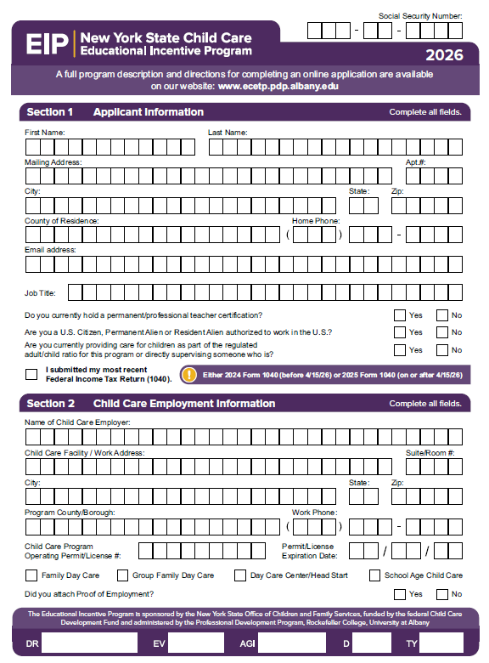
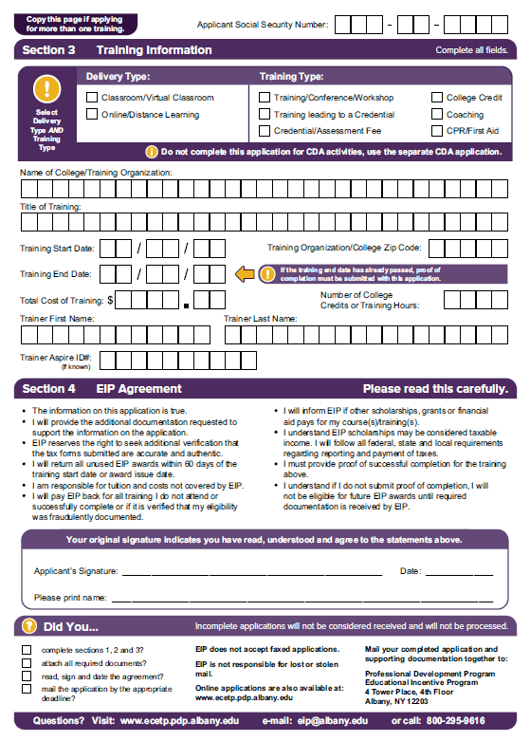
Please mail or drop off to:
NIAGARA COMMUNITY ACTION PROGRAM
1521 Main Street,
Niagara Falls, NY, 14305

(Please do not send cash via mail, drop off only.)
For more info regarding on-site training classes:
contact Donna Striffler at (716) 285-8572 EXT. 116 or dstriffler@niagaracap.org
*Please let us know if you’re using CSEA/VOICE to cover the cost of your CPR cl ass

